Q1)

1. Its a Binomial distribution.



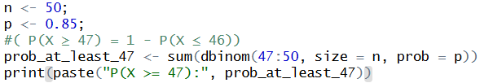

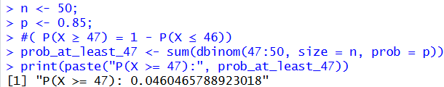

Q2)

1. X represents the number of customer calls received in one hour
2. Poisson distribution
3. 